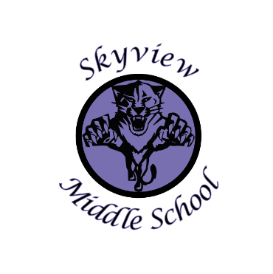 |  | Skyview Middle School  Committee Name: Site Based Council  Date: October 14, 2019  SMS Library
Meeting Facilitated by: |  | Jarrick Jensen |  | Type of meeting: | Site Based Council
Note Taker: |  | Shannon Dwyer
Attendees: |  | Members: Shannon Dwyer, Jarrick Jensen, Jill DuFloth, Pam Parker, Krista Arthur, Andrew Arthur, Kristin Jones, Shannon Dwyer, Marshall Deraeve, Sarge Truesdell  Guests: Rob Ross (Parent), Patti Truesdell (community member)
---------- Agenda Topics ----------
Call To Order: 3:30 |  |  | Approval of Agenda: SD PP
Approval Of Minutes: JD JJ
Old Business: None
New Business:
1 | 2019-20 SIP & SEL Goal—Review  Mr. Truesdell discussed the school development plan goals (personalized learning and data based decision-making) in detail as well as the Social Emotional learning goal (2 specific areas of the Hanover survey) and all actions steps.
2 | Possible 2019-20 SBC Goal:  By the end of the 2019-20 school year the Skyview Site Based Council will work alongside the Skyview Middle School staff to provide 200+ hours of service-learning opportunities for our students so that they can have a positive impact in our community.
3 | School Wide Field Trips  Possible Alyeska Dates=12/20, 2/14, 3/6
4 | 710/100 account balance  Discussion of spending money on TV/Display in commons
5 | Current Enrollment=406  2020-21 Projected Enrollment=401
6 | Student Council Monthly Update
7 | Body Fat testing in PE  Mrs. DaRaeve brought up the body fat testing in PE and asked if we could research a different/more accurate way to test.
8 | 2019-20 Site Based Council Meeting Dates: 11/18, 1/20, 4/13 @ 3:30pm
9 | Meeting adjourned: 4:31pm

