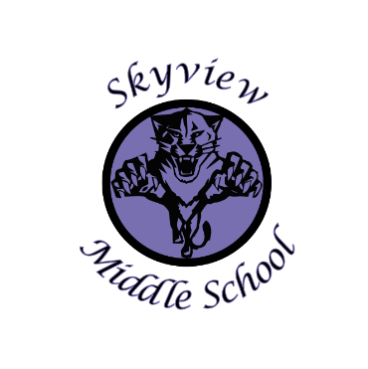 |  | Skyview Middle School  Committee Name: Site Based Council  Date: September 9, 2019  SMS Library
Meeting Facilitated by: |  | ST |  | Type of meeting: | Site Based Council
Note Taker: |  | ST
Attendees: |  | Sarge Truesdell, Pam Parker, Marshal DeRaeve, Kelli DeRaeve, Andrew Arthur, Krista Arthur, Jill DuFloth, Kristin Jones, Shannon Dwyer
---------- Agenda Topics ----------
Call To Order: 3:30 |  |  | Approval of Agenda: KA KJ
Approval Of Minutes: April 2019 Minutes Approved KA KJ
Old Business: None
New Business:
1 | Introductions of the 2019-20 SBC members  Introductions of new Skyview Middle School teachers
2 | Approval 2019-20 bylaws/member signatures
3 | Selection of Chairperson—Jarrick Jensen; Selection of Secretary—Kelli DeRaeve
4 | Review of 2019-20 School Development Plan Goals & Action Steps
5 | Discussion about 2018-19 SBC Goals & Discussion of 2019-20 potential site council. Skyview SBC goals will be finalized at the October Meeting.
6 | 710/100 account balance discussed in detail
7 | Current Skyview Enrollment=407. 2020-21 enrolment prediction to be discussed at October Meeting
8 | Student Council Update provided by Mrs. Pothast
9 | 2019-20 Site Based Council Meeting Dates: October date TBD (KPBSD Budget Meeting), 11/18, 1/20, 4/13 @ 3:30pm
10 | Meeting adjourned: 4:29pm

