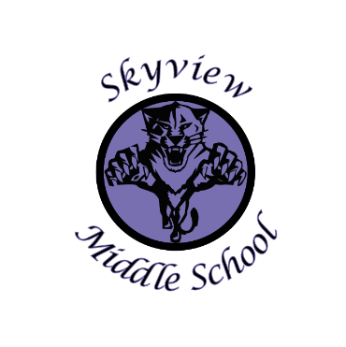 |  | Skyview Middle School  Committee Name: Site Based Council  Date: April 8, 2019  SMS Library
Meeting Facilitated by: |  | JA |  | Type of meeting: | Site Based Council
Note Taker: |  | KJ
Attendees: |  | Sarge Truesdell, Jonus Angleton, Kristin Jones, Carrollynn Peterson, Emily Manley, Krista Arthur, Andrew Arthur.
---------- Agenda Topics ----------
Call To Order: 3:32pm |  |  | Approval of January Agenda: ST KJ
Approval Of November Minutes: ST JA
Old Business: None
New Business:
1 | Discussion/Review of the 2018-19 School development Plan & Action Steps.
2 | Discussion of the 2018-19 SBC goals—205 community work service hours this year. We would like to use this as a baseline for the same goal in 2019-20.
3 | Handbook proposed Changes—approved by site council but waiting on one addition from Mr. Angleton for the DC trip.
4 | Soldotna Prep/SOHI Consolidation & RCA to Skyview—Community Meeting @ SOHI 6pm on 4/11
5 | 710/100 account balance review & discussion 7 Skyview Middle School Current enrollment 395 & 2019-20 enrollment projected enrollment 429
6 | Special Thanks to our Members who are leaving us:  Mr. Angleton—Ms. Manley—Lilly—Mr. Sorrell—Ms. Peterson
7 | STUCO update—Mrs. Pothast came and presented the final “Birthday Bag” total at nearly 400 items.
8 | 2018-19 Remaining Site Based Council Meeting Dates: None 2019-20 dates: 9/9/19, 10/14/19, 11/18/19, 1/20/20, 4/13/20
9 | Meeting adjourned: 4:15pm

