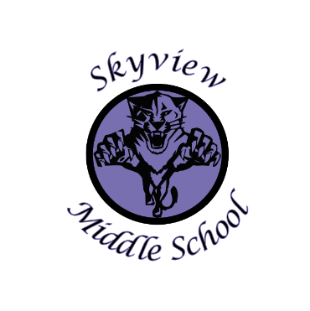 |  | Skyview Middle School  Committee Name: Site Based Council  Date: January 14, 2019  SMS Library
Meeting Facilitated by: |  | JA |  | Type of meeting: | Site Based Council
Note Taker: |  | KJ
Attendees: |  | Sarge Truesdell, Jill DuFloth, Kristin Jones, Carrollynn Peterson, Emily Manley, Krista Arthur, Andrew Arthur.
---------- Agenda Topics ----------
Call To Order: 3:32pm |  |  | Approval of January Agenda: ST KJ
Approval Of November Minutes: ST JA
Old Business: None
New Business:
1 | Discussion/Review of the 2018-19 School development Plan & Action Steps.
2 | Discussion of the 2018-19 SBC goals--We will work alongside the Skyview Middle School staff to provide service-learning opportunities for our students so that they can have a positive impact in our community. 205 community work service hours during the student flex day.
3 | Student Flex day discussion/follow up
4 | Handbook proposed Changes—approved by site council
5 | 710/100 account balance review & discussion
6 | Skyview Middle School Current enrollment (403) & 2018-19 enrollment projection (416). 2019-20 enrollment projected enrollment 429
7 | STUCO update
8 | 2018-19 Remaining Site Based Council Meeting Dates: 4/8/19
9 | Meeting adjourned: 4:17pm ST EM

