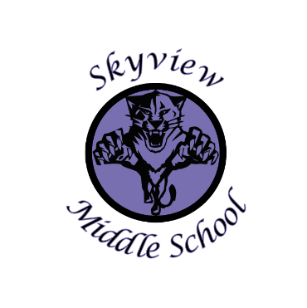 |  | Skyview Middle School  Committee Name: Site Based Council  Date: October 30, 2018  SMS Library
Meeting Facilitated by: |  | JA |  | Type of meeting: | Site Based Council
Note Taker: |  | KJ
Attendees: |  | Sarge Truesdell, Jill DuFloth, Jonus Angleton, Krista Arthur, J Webster, Nick Sorrell, Kristin Jones, Carrollynn Peterson, Emily Manley, Andrew Arthur
---------- Agenda Topics ----------
Call To Order: 5:00pm |  |  | Approval of Agenda: JA JD
Approval Of Minutes: JA KA
Old Business: None
New Business:
1 | District Budget Meeting/Presentation to follow Skyview SBC Meeting
2 | Discussion of Building use funds & possible fund raising projects including school reader board.
3 | Discussion/Review of the 2018-19 School development Plan & Action Steps.
4 | Discussion of the 2018-19 SBC goals. Community work service opportunities for Skyview Middle School students
5 | 710/100 account balance review & discussion
6 | Skyview Middle School Current enrollment (408) & 2018-19 enrollment projection (416). 2019-20 enrollment projected enrollment 429
7 | STUCO update from Mrs. Pothast
8 | 2018-19 Remaining Site Based Council Meeting Dates: 11/12/18, 1/14/19, 4/8/19
9 | Meeting adjourned: 5:49pm

