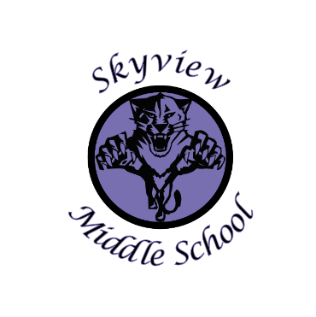 |  | Skyview Middle School  Committee Name: Site Based Council  Date: September 10, 2018  SMS Library
Meeting Facilitated by: |  | ST |  | Type of meeting: | Site Based Council
Note Taker: |  | ST
Attendees: |  | Sarge Truesdell, Jill DuFloth, Jonus Angleton, Krista Arthur, Jlee Webster, Nick Sorrell, Kristin Jones
---------- Agenda Topics ----------
Call To Order: 3:30pm |  |  | Approval of Agenda: NS 2nd JA
Approval Of Minutes: JA 2nd JD
Old Business: None
New Business:
1 | Approval of 2018-19 SBC bylaws. Discussion of SBC mission. Process, membership, responsibility, attendance & voting, and 2018-19 meeting dates & times. Membership agreement signatures
2 | Selection of a 2018-19 Chairperson: Jonus Angleton  Selection of 2018-19 Secretary: Kristin Jones
3 | Discussion/Review/approval of the 2018-19 School development Plan & Action Steps.
4 | Discussion of the 2018-19 potential SBC goals. Discussion will continue at October SBC meeting.
5 | 710/100 account balance review & discussion
6 | Skyview Middle School Current enrollment (416) & 2018-19 enrollment projection (416). 2019-20 enrollment projection to be discussed at October meeting.
7 | STUCO update from Ms. Pothast
8 | 2018-19 Site Based Council Meeting Dates: 10/30 (rescheduled from 10/18), 11/12/18, 1/14/19, 4/8/19
9 | Meeting adjourned: 4:40

